

Making changes to the

place you rent
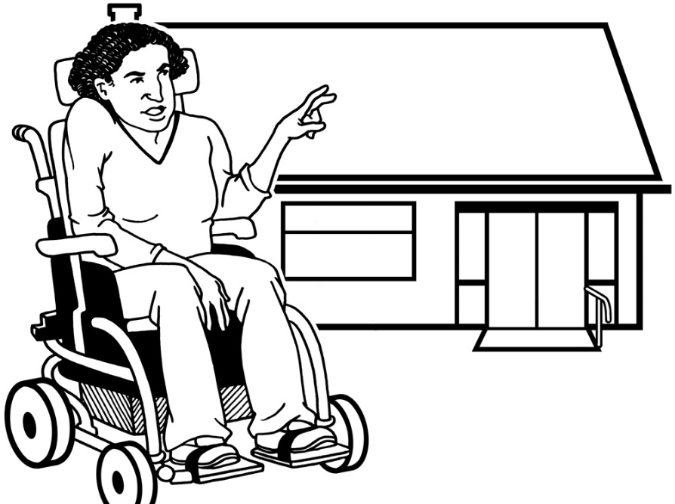

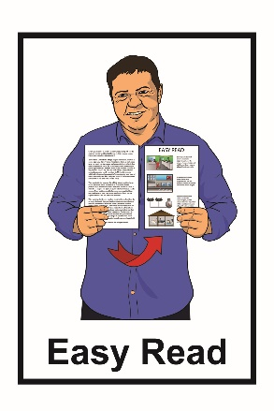

November 2021
What you will find in here


Page number:

What is this document about?....................2


What do Tenancy Services do?............. 4



Asking to make changes to a property……6


Making minor changes to a property…….13


What landlords must do when a tenant asks them to make a minor change……..19


What is a minor change?.........................22


Where to find more information………….26

What is this document about?

This is an Easy Read document by Tenancy Services for people who are renting the property they live in.


Renting is when you pay money to live in a place that belongs to someone else.


In this document a property means the type of building that you live in.


This could be:

- a house
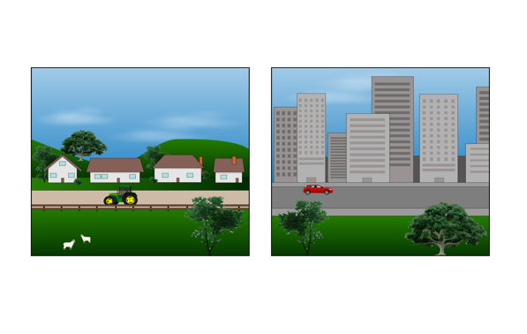
- an apartment

- a townhouse

- another type of building.


This document tells you what you need to do before you make any changes to the property.


You can read more information on the Tenancy Services website.

www.tenancy.govt.nz



The information on this website is not in Easy Read.

You can ask someone to:
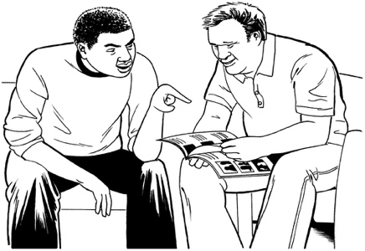
- read it through with you

- help you understand it.

What do Tenancy Services do?

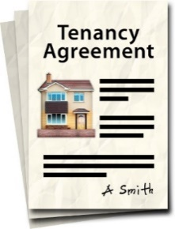
Tenancy Services can support tenants and landlords with:


- knowing the rules about renting

- questions about renting

- knowing what kinds of things they are allowed to do

- knowing what kinds of things they are not allowed to do.




Tenants are people who pay money to live in a place that belongs to someone else.

Landlords are people who own the homes that tenants live in.

Tenants are also sometimes called renters.

Asking to make changes to a property


If tenants want to make any changes to the property they:

- should follow any rules in their tenancy agreement
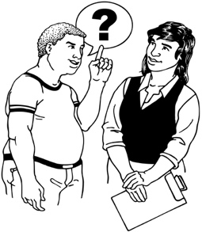

OR

- get consent from their landlord before they make any changes.


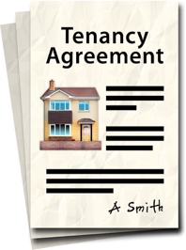
A tenancy agreement is a document that you both sign at the start of the tenancy.





The time that someone lives in a rented property is called a tenancy.

A tenancy agreement sets out the rules about the tenancy for:

- the tenant

- the landlord.


Consent is when you:

- have a choice to say yes or no

- choose to say yes.


Getting consent before making a change means that the landlord:

- understands the changes that the tenant wants to make
- is happy for the tenant to make the changes.
There are some changes a tenant cannot make unless their landlord says yes.


If you are a tenant you must get consent before you:

- change what the property looks like

- make any big repairs to the property

- change any fixtures in the property

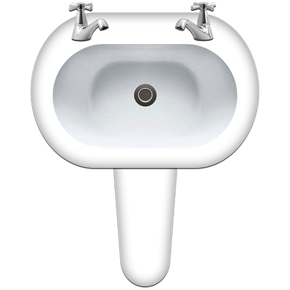
- add any fixtures to the property.

A fixture is something that is fixed to the rental property.

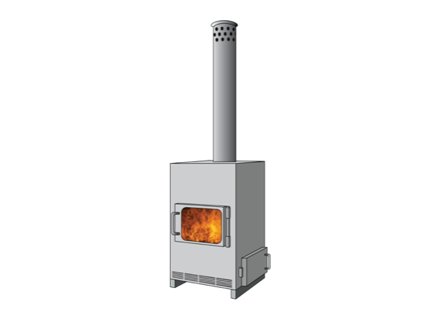
Fixtures can include things like:

- boilers and heating systems
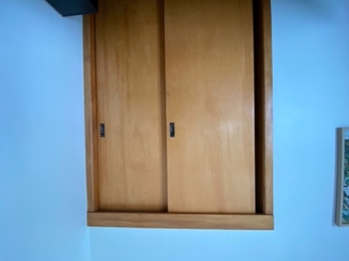
- built in wardrobes
- kitchen cabinets and cupboards

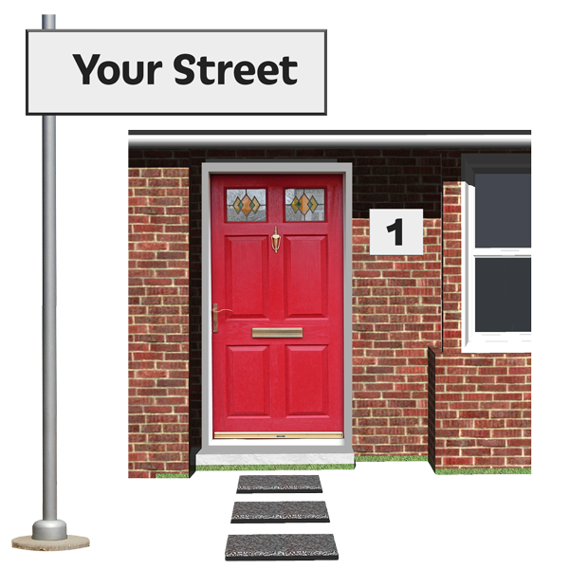
- carpets
- doors

- bathroom items like:
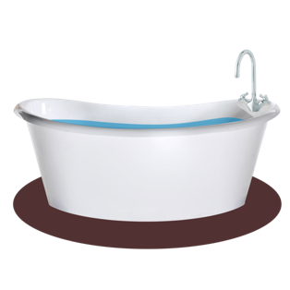
- baths
- showers
- sinks.
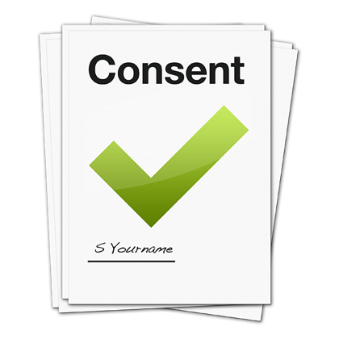
The landlord must give their consent in a letter to the tenant before any changes can be made.



The landlord can only say no to the changes if they have a good reason.

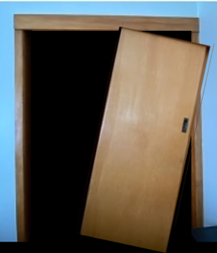

If you are a tenant you must not remove any fixtures that will:

- damage the property

- cause any damage that cannot be repaired.

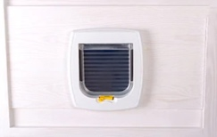

Sometimes a landlord will let you add a new fixture if you both agree it can stay in the property when you move out.


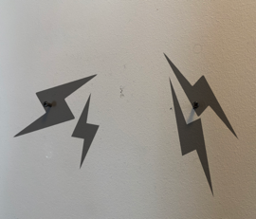

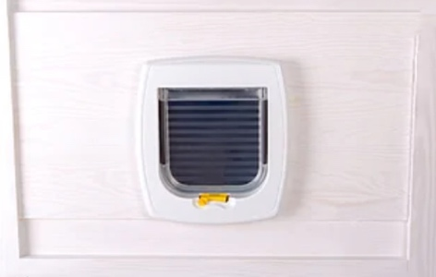
This is because it would cause damage to the property if it was removed.

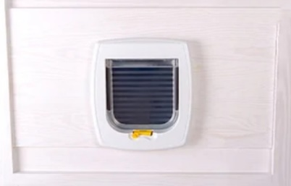
Sometimes fixtures that have been put up by the tenant can later belong to the landlord.


This happens when the fixture has not been removed when the tenant moves out.

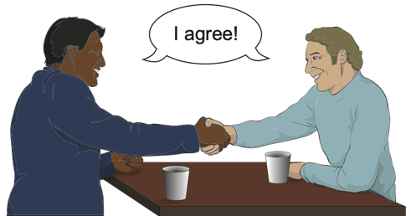
This does not happen if the tenant has agreed something else with their landlord.

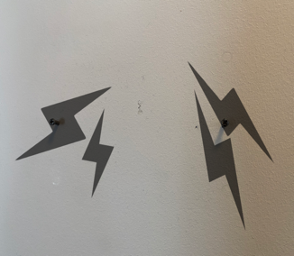

You must tell your landlord if you cause any damage when removing fixtures.


Your landlord can then tell you if they want you to:

- fix the damage yourself

- pay the landlord money so they can fix the damage.


You can find more information about paying money to fix any damage on the Tenancy Services website:

www.tenancy.govt.nz



The information on this website is not in Easy Read.

You can ask someone to:

- read it through with you

- help you understand it.

Making minor changes to a property


The Residential Tenancies Act 2020 is a law.

It explains the rules about rented properties that everyone must follow.

You can find out more about it on the Tenancy Services website:

https://www.tenancy.govt.nz/law-changes/


The information on this website is not in Easy Read.

You can ask someone to:

- read it through with you

- help you understand it.

The Residential Tenancies Act means that you can ask your landlord if you can make minor changes to the property.



A minor change is a small change.

The landlord cannot say no to a minor change without a good reason.

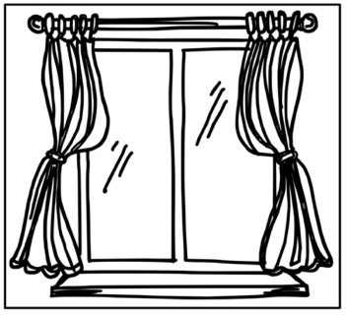
Minor changes include what is known as minor fixtures like:

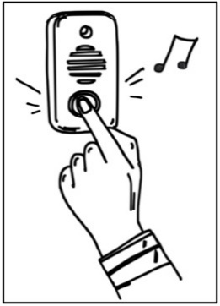
- putting up curtains
- adding a visual fire alarm

- fitting a doorbell.

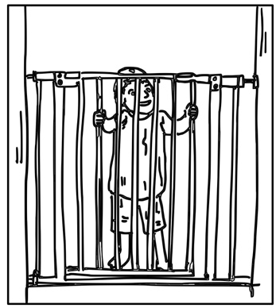
Minor fixtures can also be things like:

- making a house safe for a young child to live in such as fitting a baby gate
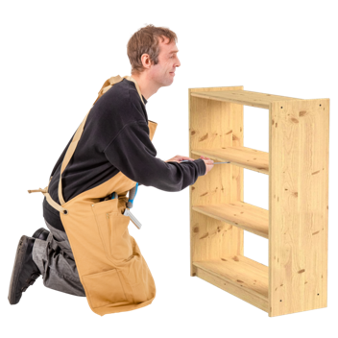
- making a house safe from earthquakes such as fixing a bookshelf to the wall.


Before you make these changes there are some things you must do.


You must write to your landlord to ask them if you can make a minor change.


You must not make any changes until your landlord says that it is okay.

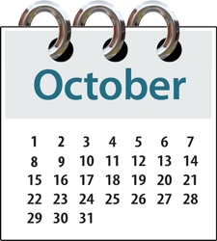
Your landlord must reply to you within 21 days.
DATES



Your landlord can ask you for more time to make their decision.



The landlord will not usually pay for any minor changes.

You will have to pay for any minor changes yourself.

You must remove any minor fixtures you have fitted when you move out of the property.

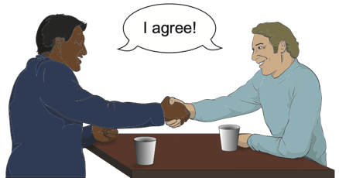
You do not have to do this if the landlord has agreed that any minor fixtures can stay.




When you move out of the property you must make sure it is in good condition.


This means it should be as close as possible to the same condition it was in before you made the minor change.


You can download the form called Request to make a change to the property from the Tenancy Services website.


https://www.tenancy.govt.nz/assets/forms-templates/request-to-property-change.pdf

This form is not in Easy Read.

You can ask someone to:
- read it through with you

- help you understand it.

What landlords must do when a tenant asks them to make a minor change


There are some things a landlord must do when a tenant asks them if they can make a minor change.


A landlord must reply to the tenant in writing to tell them if they think the change is a minor one.
DATES

They must do this within 21 days.


The landlord must write to the tenant to say yes or no to the minor change within 21 days.



If the landlord cannot decide if the change is a minor one they can write to the tenant to ask for more time to think about it.



Landlords must not say no to minor changes without a good reason.

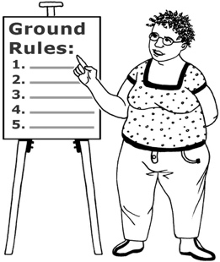

They can ask the tenant to follow some rules when they make a minor change if these rules are fair.


You can download the form called Response to request to make a change to the property from the Tenancy Services website.

www.tenancy.govt.nz

This form is not in Easy Read.

You can ask someone to:
- read it through with you

- help you understand it.

What is a minor change?

A minor change to a property can be:

- adding a minor fixture to the property

- changing something in the property

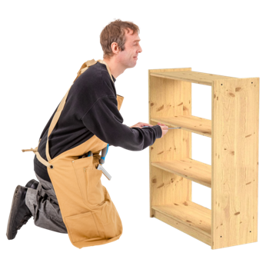
- repairing something in the property

- adding something new to the property.


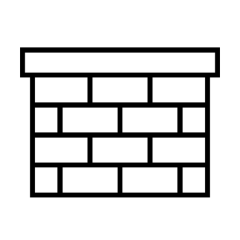

A minor change must be unlikely to
damage the property.




It should be easy to remove so that the property can go back to how it was before the change.
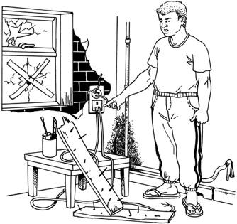
A minor change will not make the property unsafe to live in.


It will not affect how the property has been built in any way such as:
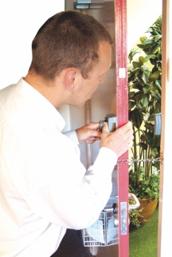
- changing how safe the property is
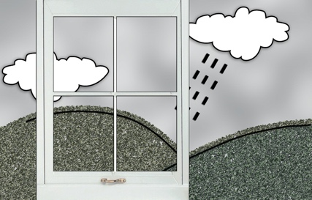
- changing how secure the property is
- changing how the weather might affect the property
- changing what the property looks like.

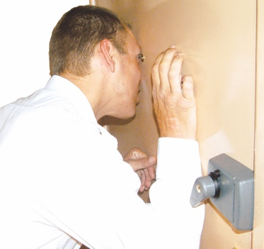
Secure means doors and windows can be locked so you feel safe to live in the property.

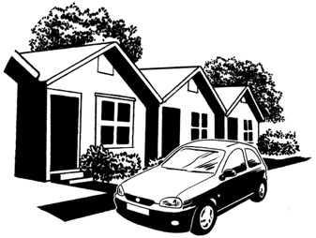
A minor change does not affect how anyone:


- uses the property

- enjoys living in the property.


Regulatory
consent
A minor change does not need
regulatory consent before it can be made.



Regulatory consent is the official consent you need to get from your local council.

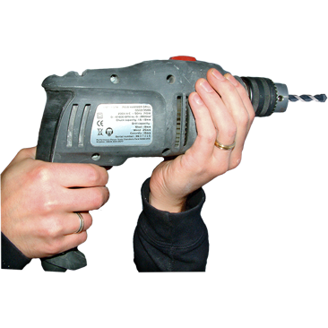
It is important that you get this consent before you do certain types of work on a property.


The kind of work you need regulatory consent for includes:

- making the property bigger by building extra rooms
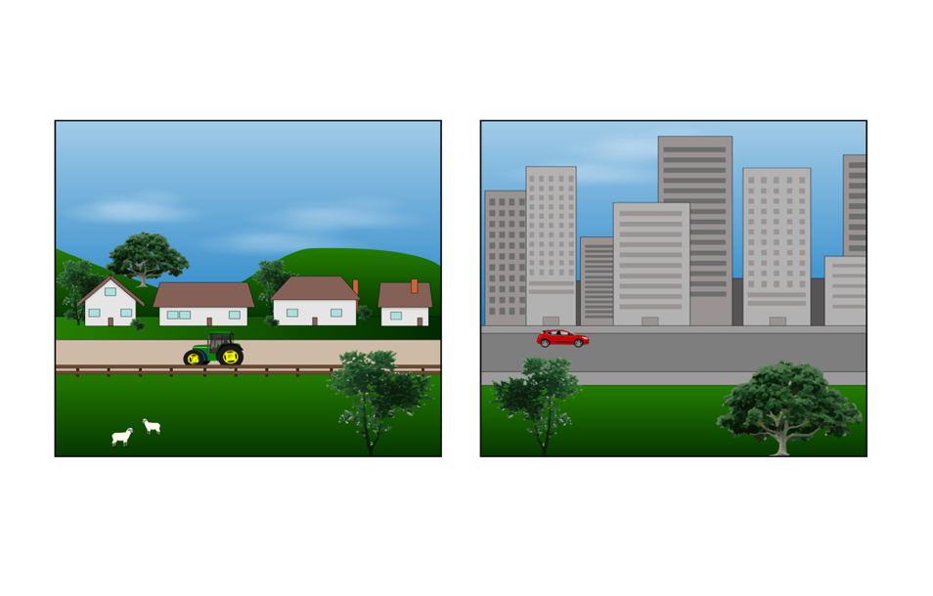
- splitting up any land that is part of the property.

A minor change does not break any
REGULATORY
RULES
regulatory rules.


Regulatory rules are laws that apply to the property such as:

- how the property can be used

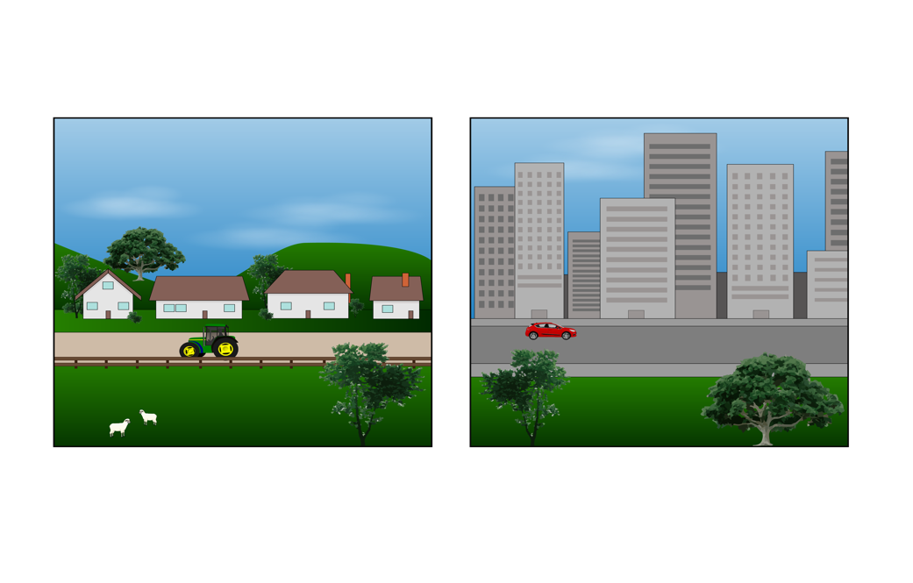
- how any land connected to the property can be used

- what kind of changes to the property the property owner can make.
Where to find more information

You can find more information on the Tenancy Services website:

www.tenancy.govt.nz


You can also phone Tenancy Services on:

0800 836 262

This information has been written by Tenancy Services.
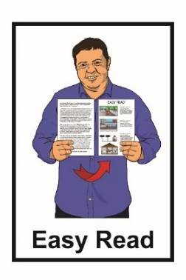
It has been translated into Easy Read by the Make It Easy service of People First New Zealand Inc. Ngā Tāngata Tuatahi.

The ideas in this document are not the ideas of People First New Zealand Inc. Ngā Tāngata Tuatahi.


Make It Easy uses images from:

- Changepeople.org


- Photosymbols.com

- Sam Corliss


All images used in this Easy Read document are subject to copyright rules and cannot be used without permission.

